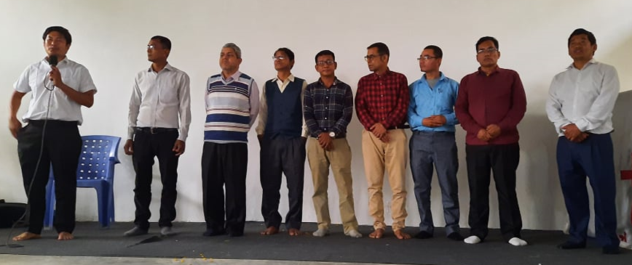
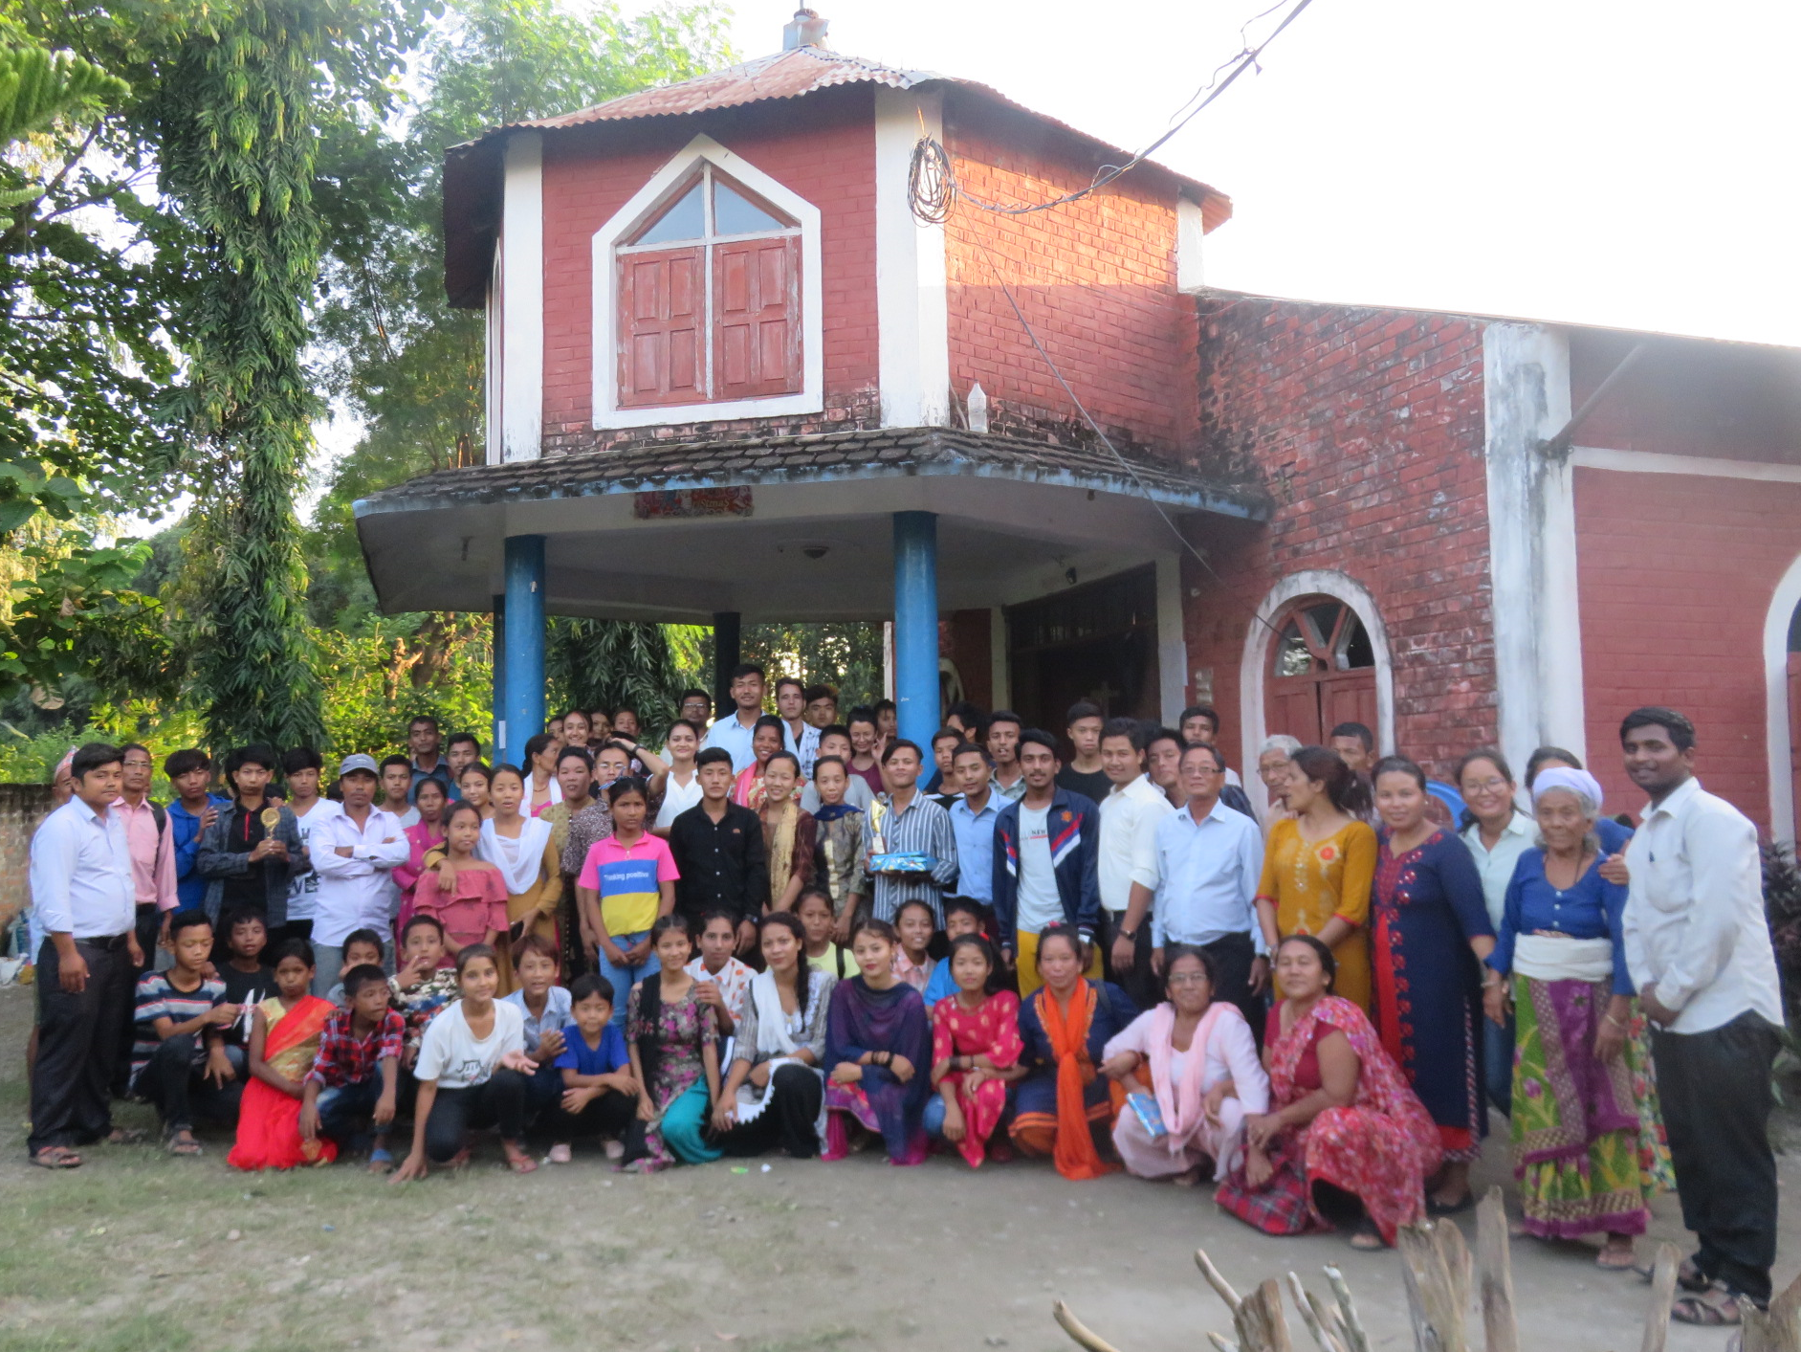

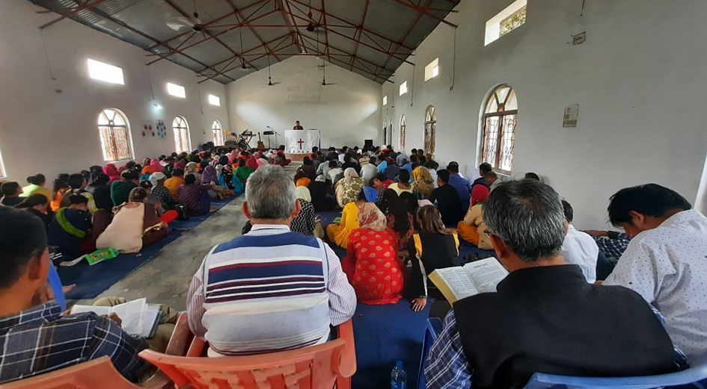
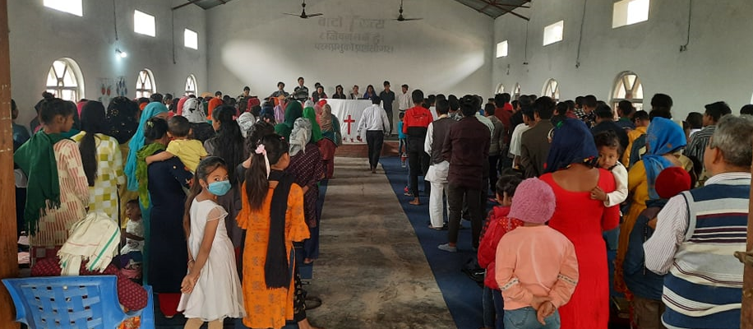

Respected Dr. Sab,
Foreign mission committee, Deacon Lee and Director Elder Ahn
Elders, Pastors, Deacons and Suwon Church Family
Jaimashi to all of you in the name of our Lord.
We admire you very much as true warriors for Jesus Christ. Your Friendship helps us to produced pastors, Leaders and college students and Church Building and livehood changing at life.
After lockdown Milan Church as well as all the Chori Church are opened for fellowship on Saturday.
Every Wednesday we are having leadership meeting. It is helping us to discus and Bible study.
Milan Church is planning to reconstruct toilet because it’s became fifteen years old now. In Milan Church there will be many seminar and program because Milan church is center for all.
November first week Milan Church is focusing and planning to have Vocational Bible School for Sunday school students. Because of Lockdown Children also are having depress and attaching with mobile so this program will refresh for them. We are targeting 300 Children on this VBS seminar so please pray for us.
Last week Milan Youth conference was held on Milan Church. More than 200 youths have participated and it was blessed together.
On Wednesday Milan Pastors Board was held on Milan Church. After lockdown this is the first meeting together. I have given Suwon Church regard to all, Milan Pastors is very much happy. Milan Pastors Board also send regard jaimashi to Suwon Church family.
Some of the plans and Prayers, Milan Pastors Board is list out off for 2022.
- Radio program: Near our village we have Bagmati Radio so we want to share Good News and Christian song to play. Many People can hear and bless through this media.
- Training Center: We want Milan Church own training center for to equip and build the leaders for new generation. We want to use education Building for training so we need some of the material need.
- Church Building: For 2022 we want to construct any two Church Building on Milan Chori Churches. The first of the list is Bagmati Chori Church to construct now they have bought own their Church land
- Multipurpose vehicle : We want to buy jeep vehicle for Milan Church income source it will helps to support pastors and leaders as well as new generation. During the mission program we can reach Palpa, Shyanja and Gorkha for ministry.
In Christ
Ps. Amar Thapa
Milan Church Nepal

