Respected Dr. Sab,
Foreign mission committee, Deacon Lee and Director Elder Ahn
Elders, Pastors, Deacons and Suwon Church Family.
Warm Greeting to you all.
We are very much happy to share our ministry on Children VBS Camp at Milan Church.
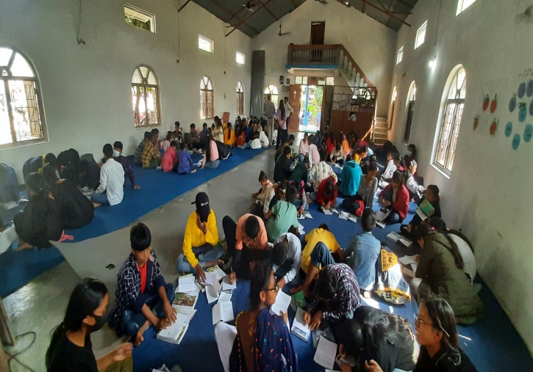
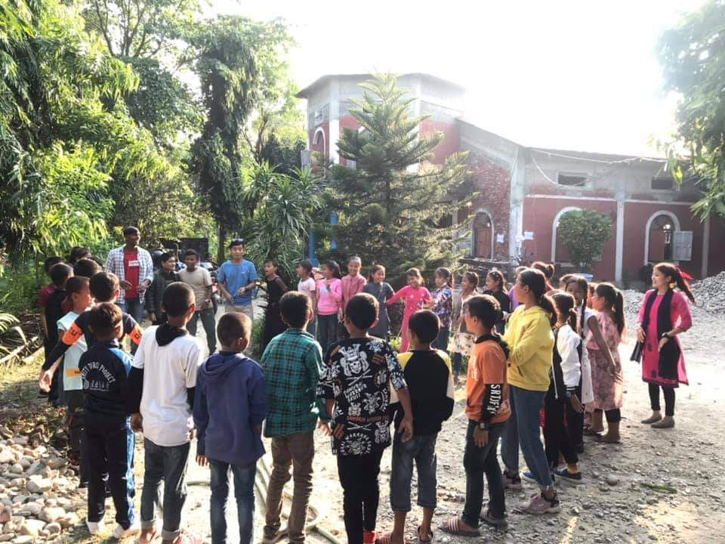
It was really blessed for every child and others too. We had having two groups the VBS Camp. One was Milan Church and Rajghat Bible Church. Milan church had almost 300 children and Rajgat Bible Church had almost 280 children. There were enough teachers to teach them. We taught them different kinds of Songs, dances, Bible stories, games etc. There were different kinds of ages. So, we divided into 6 groups at Milan Church and Rajgat Bible Church too. We sew, all child were really felt enjoyable with songs, dances, Bible stories, Jokes, games etc.
We want to conduct each year to encourage Children through such program. The Children are the future Leaders for Milan Church ministry. We want your participate and involve in up coming day.

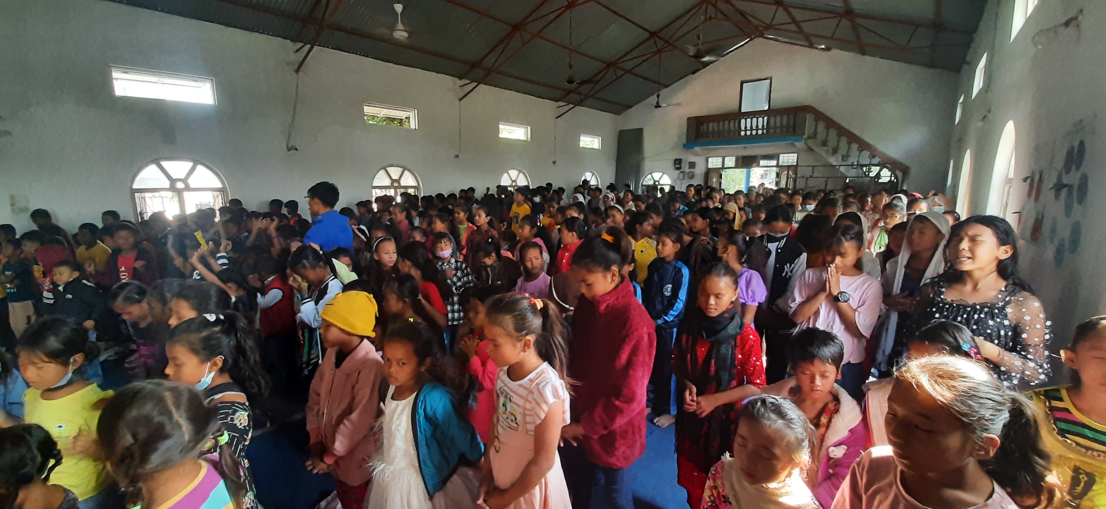
In Christ
Ps. Amar Thapa
Milan Church Nepal

