Respected DR. Sab And Elder HS LIM
Foreign mission committee, Deacon Lee and Director Elder Ahn
Elders, Pastors, Deacons and Suwon Church Family.
Jaimashi to you all on be half Hariwon Church family. In God grace and through your prayer Hariwon Church family are fine. Pastor Naryan Rai and Hema Rai send you jaimashi. They are doing hard work and looking after Hariwon Church.
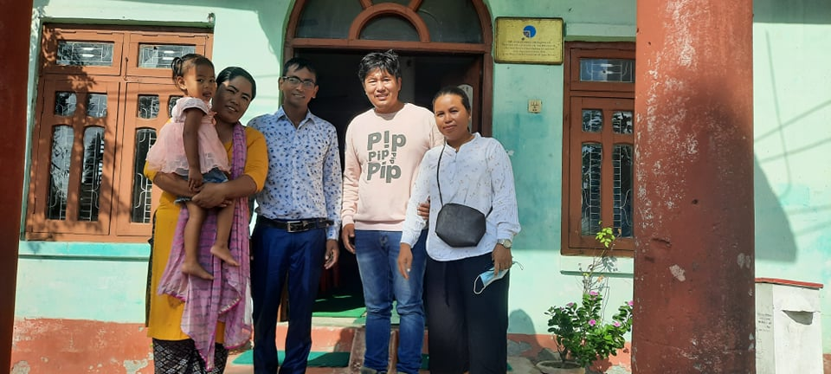
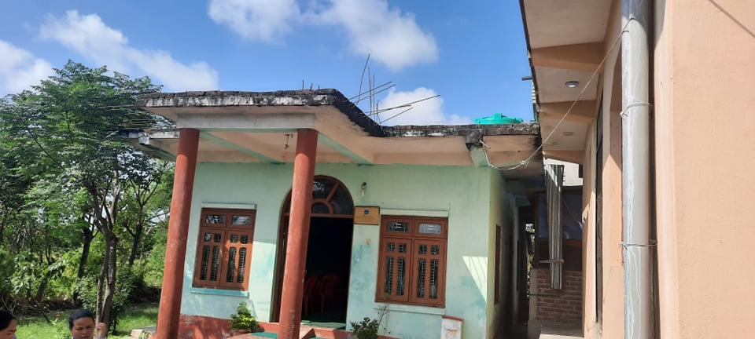
Hariwon Church ministry.
- Youth ministry: Last week in Hariwon Church youth were having music class. Youth are actively participating and helping the Church program. Samuel is helping the youth in taking guitar class and computer class. Samuel is working in Hariwon municipality as well as on business teaching computer.
- Women Fellowship: Every Saturday women fellowship is having after Saturday service. Every first month of Monday having fasting prayer.
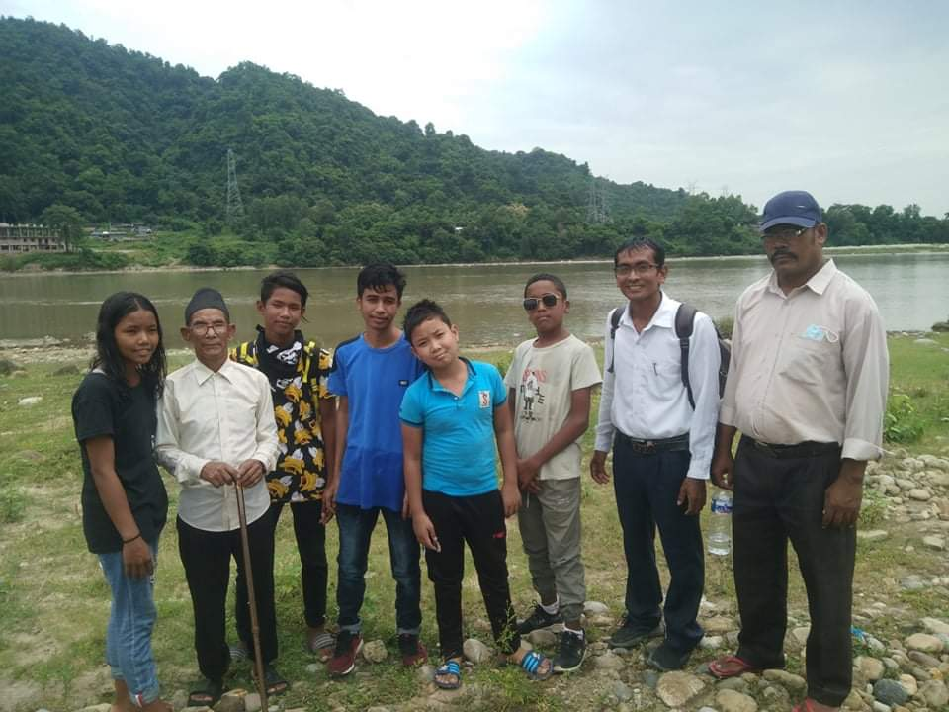
- Last month Hariwon Church arranged baptism program on that day five person have baptized.
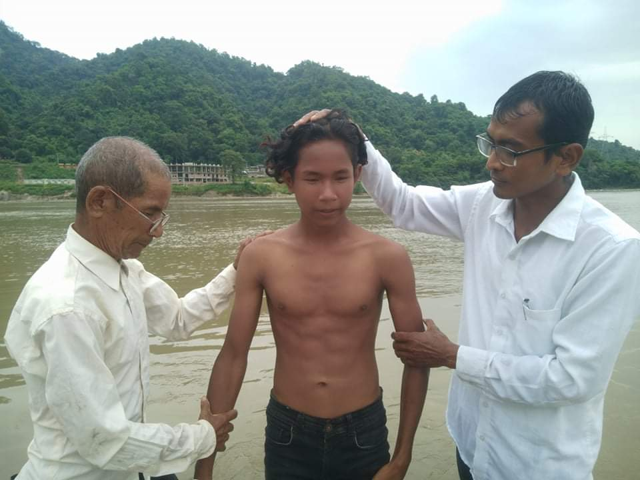
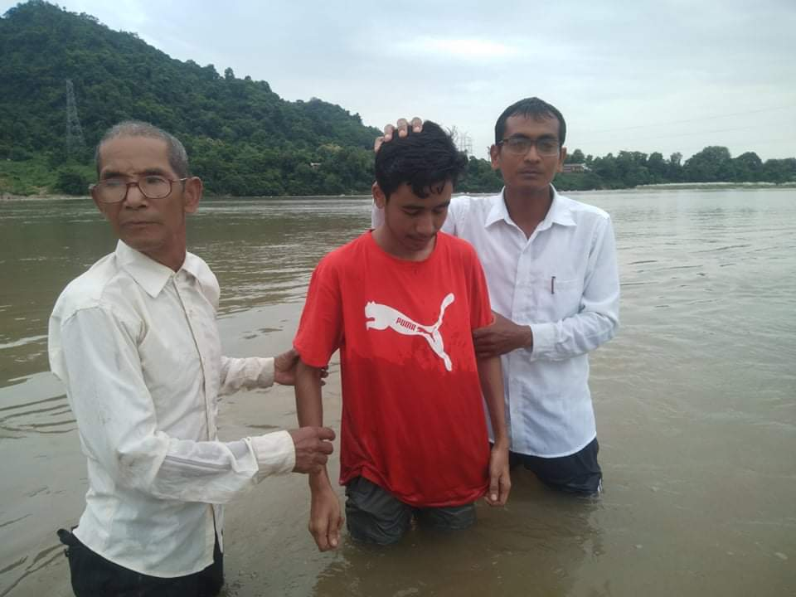
Hariwon Church have five Jhundas and having cottage fellowship every Tuesaday and Thursday. Every Wednesday is Leadership meeting.
Prayer Concern
- Planning to starts Saturday worship service in two Jhundas so needs leaders.
- Hariwon Church compound area has to make it wall for safety.
- Hariwon Church have not room for Sunday School so Church is planning to build up room for them.
In Christ
Ps. Amar Thapa
Milan Church Nepal.

