Respected Dr. Sab and Elder Lim
Foreign mission committee, Deacon Lee and Director Elder Ahn
Elders, Pastors, Deacons and Suwon Church Family.
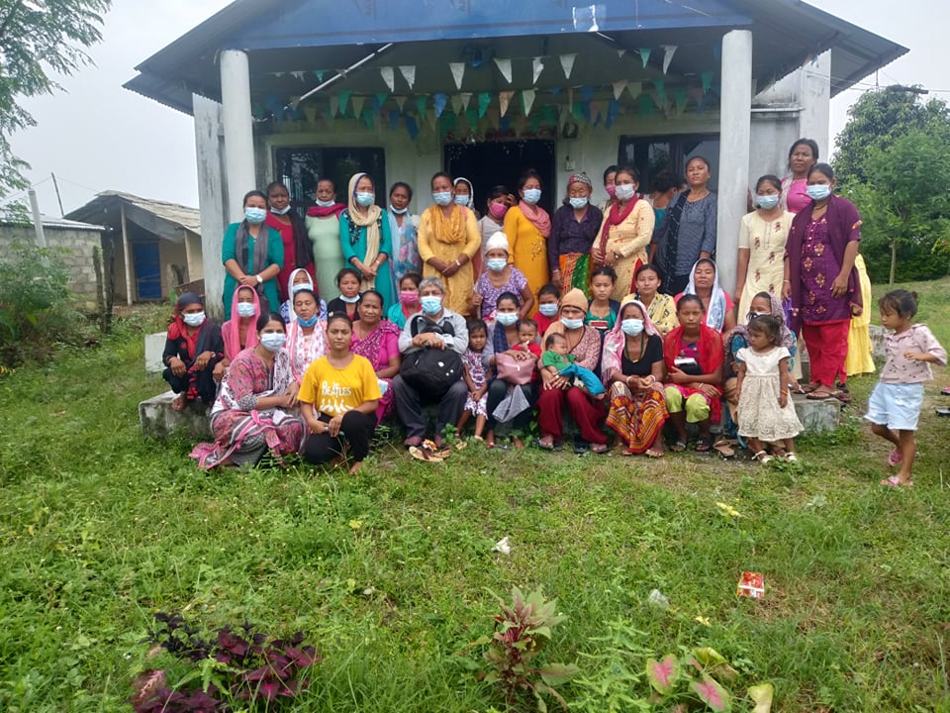
Warm Greeting to you on behalf from Gerayat Church family.
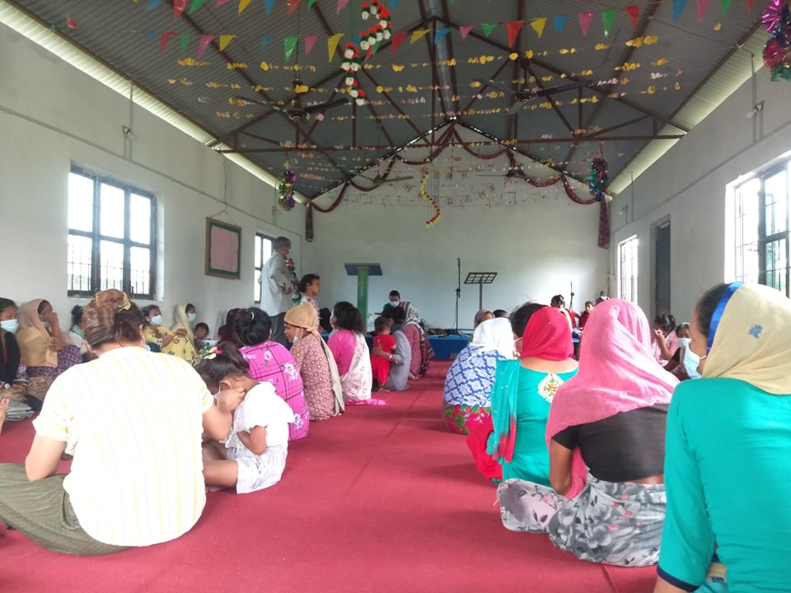
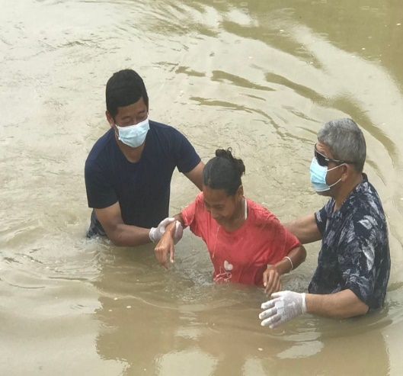
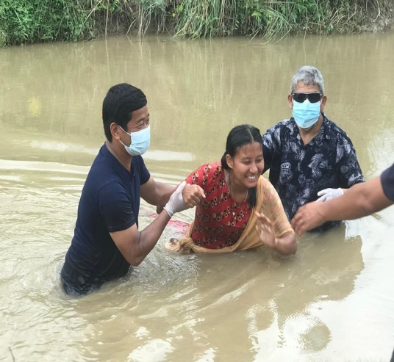
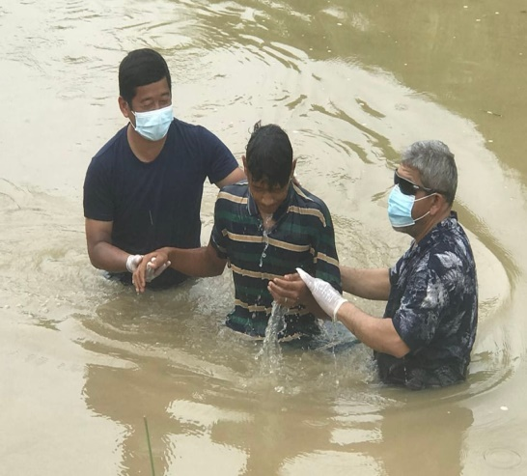
Gerayat Chori Church family is well in His grace. By the Grace of God Gerayat Church is doing good in God kingdom. Pastor Man Bahadur Thing is serving the Lord faithfully even he is lay man. His wife is not keeping well because she has physical illness. During the Lockdown period also pastor Man Bahadur Thing reached sick people for prayer.

Last month seven members are baptized. Please pray for them to grow in Christ.
Prayer concern
- Future Leader has to build up so Gerayat Church is praying theologically train leader.
- Planning to build up church compound and build toilet.
- Three Jhundas are running now
IN CHRIST
Ps. Amar Thapa
Milan Church Nepal.

